JOB APPLICATIONS TRACKING SYSTEM

**1. Introduction:**

# OVERVIEW:

An application tracking system **(ATS)** is software for recruiters and employers to track candidates throughout the recruiting and hiring process. This software can come equipped with capabilities ranging from simple database functionality to a full – service suite of tools that makes it easy for business of any size to filter, manage, and analyze candidates.

# PURPOSE:

# 

It is saves a lot of time. The ATA then uses third information to create a profile for the ideal candidate. Use recruiting software. Managing the candidates. Drive project time line.A candidate upload resumes, send applications, interacts with recruiters.

# 2. Problem Definition & Design Thinking

# 2.1. Empathy Map

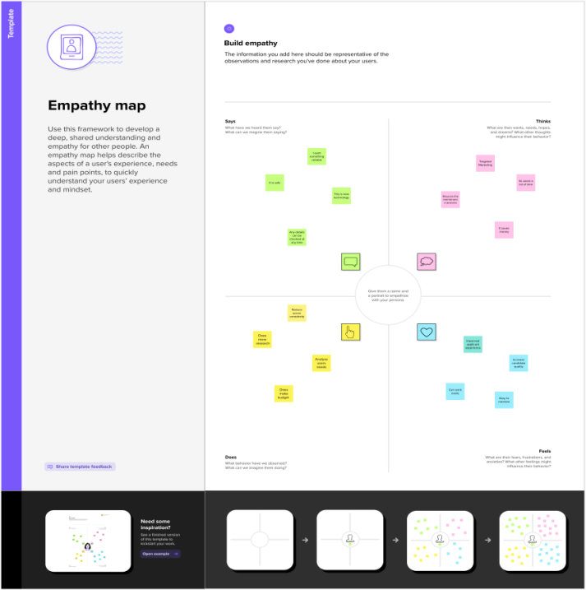

# 2.2. Ideation & Brainstorming Map

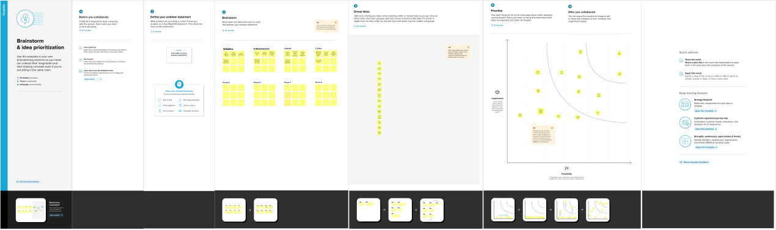

|  |  |
| --- | --- |
| Object Name | Fields in the object |
| RECRUITER | |  |  | | --- | --- | | **Field label** | **Data Type** | | **Job title** | **Text** | |
| Job | |  |  | | --- | --- | | **Field label** | **Data Type** | | **Recruiter** | **Master Detail relationship** | |

**3. RESULT:**

# 3.1 Data Model:

# 3.2. Activity & Screenshot

# Creating Developer Account:

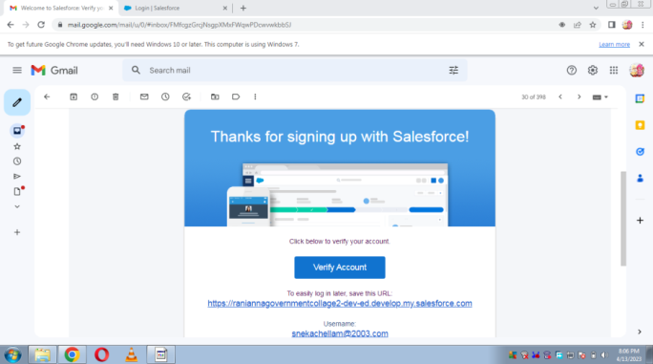

Using this [**https://developer.salesforce.com/**](https://developer.salesforce.com/) link we signup the sales force platform and finally we get the verification mail that shown in the above figure.

# Sales force Login:

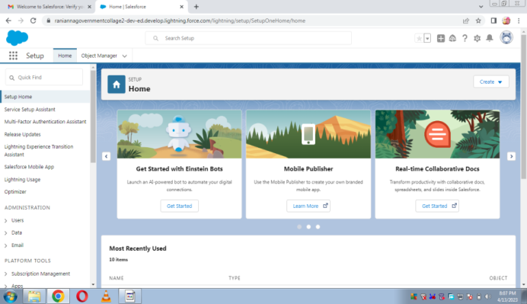

We used [**https://login.salesforce.com/**](https://login.salesforce.com/)this link to login the sales force platform. This link asked our username and password only.

# Object:

# C:\Users\AKASIYAN\AppData\Local\Microsoft\Windows\Temporary Internet Files\Content.Word\1681437725056.jpg

# Fields and Relationship:

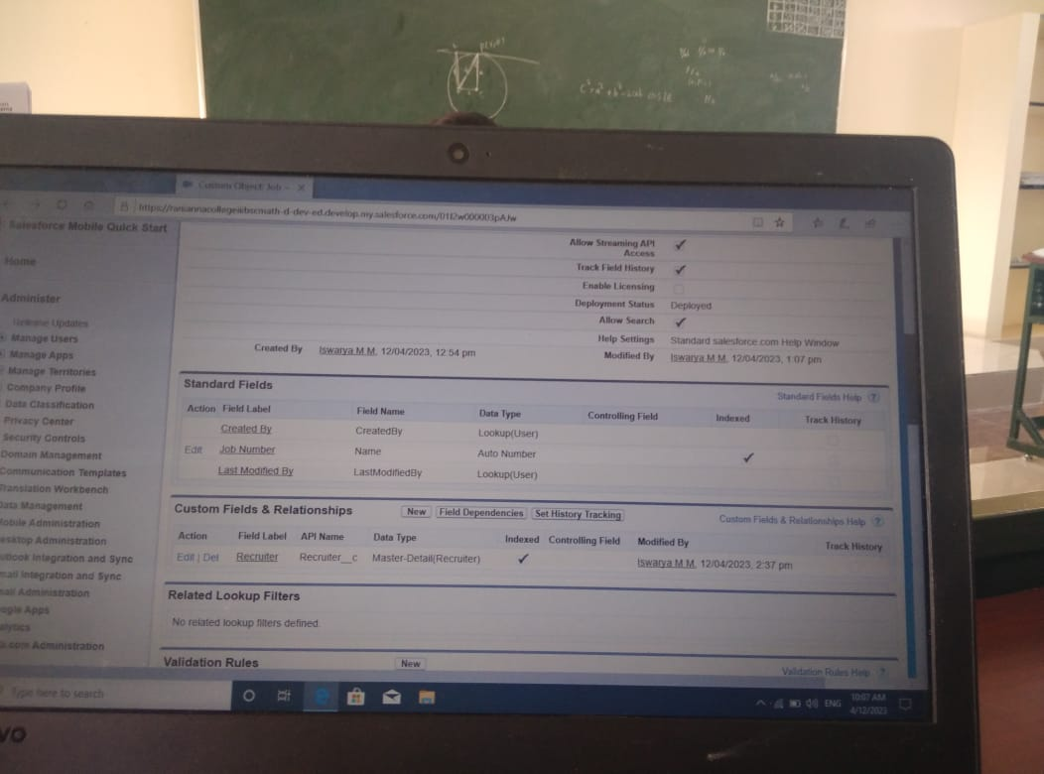

# Tab:

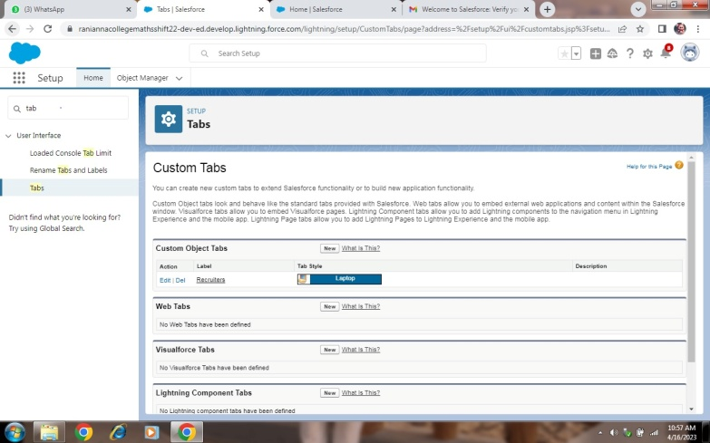

# Profile:

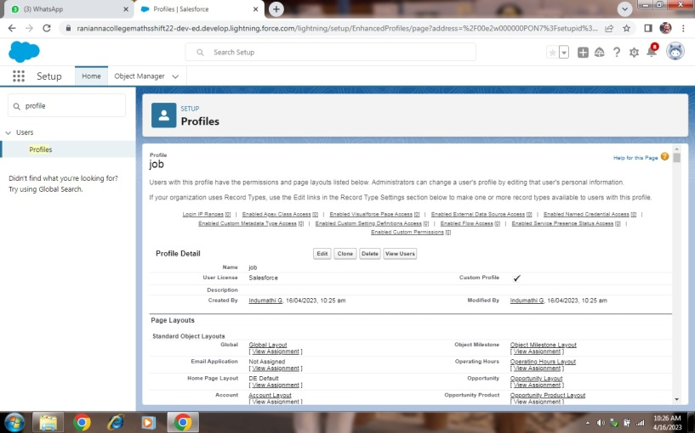

# Users:

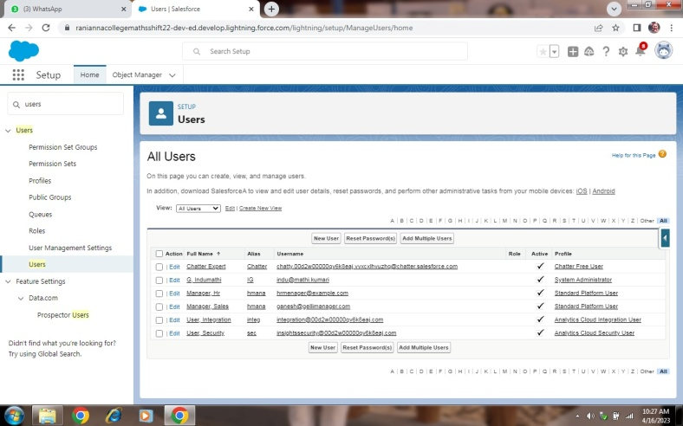

# Sharing Rule:

# C:\Users\AKASIYAN\AppData\Local\Microsoft\Windows\Temporary Internet Files\Content.Word\IMG-20230416-WA0125.jpg

Reports:

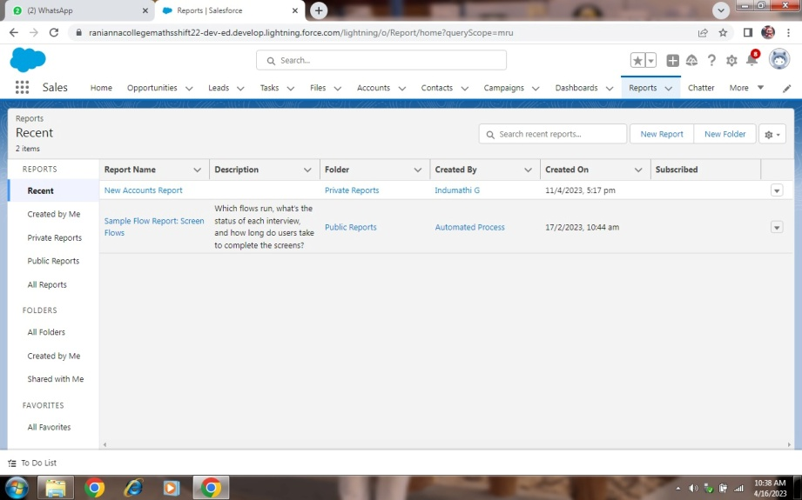

**4. Trailhead Profile Public URL**

Team Lead – https://trailblazer.me/id/mmlingeswari

Team Member 1 – https://trailblazer.me/id/indumathi02

Team Member 2 – https://trailblazer.me/id/iswam10

Team Member 3 - https://trailblazer.me/id/sasi32

Team Member 1 – https://trailblazer.me/id/tselvi36

**5. Advantages & Disadvantage**

# Advantages:

* It Affordable at the entry-level
* Great for small business
* Ready to use
* One of the kind product
* Tailored to your business needs

# Disadvantages:

* Customer experience may worsen due to staff over-reliance on the system.
* High initial costs
* Requires significant time investment
* Additional customization costs
* Doesn’t work with the hands-off approach

6. Applications

* Make a job list.
* Let’s check the quality of work.
* Feel good.
* Satisfactions.
* We need to create a connection between the office and us.

7. Conclusion

In this occupied world, it is a daunting task to keep track of all the job applications that you have applied for. So to make this task of job-hunting easier and less hassle-free the applications we are buildings will be of great help.

8. Future scope

. Student Application tracing system are robust tools that continue to innovate to match the pace of change and demand in the workforce.

* An enriched user experience
* Improved ability to leverage social platforms
* Amplified effectiveness with AI